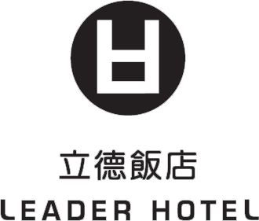
ICMMES 2012
July 23-July27, 2012

立德台大尊賢會館

Leader Hotel Taipei

RV No. 39376

Customer Information：
Last Name： First Name：
Chinese Name（IF ANY）： Title：□Prof. □Dr. □Mr. □Ms.
Institution：
TEL： FAX：
E-mail： Passport Number：
Nationality： Birthday：
Address：
Accompanying Person：
Last Name： First Name：
Flight ＆ Accommodation Information：
Check In Time：JUL _____, 2012 Flight No.________ Arrival Time：_________
Check Out Time：JUL _____, 2012 Flight No.________ Departure Time：______
Room Types：
- Superior Single  （1 Person） | - Superior Twin  （2 Person）
NT＄2,500×___Rooms | NT＄2,700×__ Rooms
Airport Pick up Service： □ Limo NT$1,800 / per car / per trip □ Van NT$2,000 / per van / per trip
□ Camry NT$1,500 / per car / per trip
NOTE：
- The foreign exchange rate will be calculated according to the payment date rate.
- Prices quoted include VAT and service charges.
- Our check-in time is after 1500 hrs (local time) and check-out time is 12 noon.
- Leader Hotel Taipei provides buffet breakfast, daily newspaper. Free access to gym and sauna.
Other Request：____________________________________________________________________________
Method of Payment：
□Visa □Master □AE □JCB
Card Number：________________________Card Holder’s Name：_______________________

Expiry Date：______________Signature：__________________________Date：__________
The hotel will ask for your credit card information and automatically charge your card for the first night's accommodation when you make your reservations.
Cancellation Policy：If you cancel 3 days prior to arrival, we will charge 50% of one night room charge.
If you cancel 1 day prior to arrival, we will charge 100% of one night room charge.
Reservation Deadline：
All reservation requests must be sent to Leader Hotel Taipei via fax or e-mail on or before Jun,23 , 2012.

